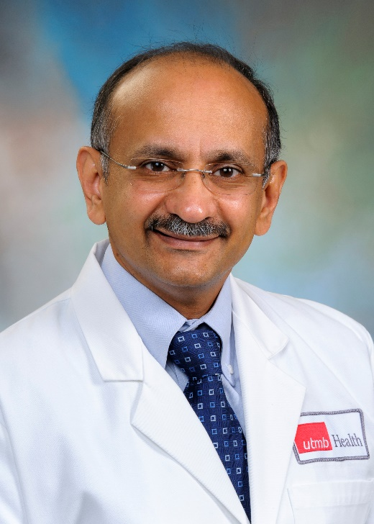
Dr. Ramkumar Menon, MS, PhD, an Associate Professor (tenured) in the Department of Obstetrics and Gynecology and Director of Perinatal Research Division. Dr. Menon received his undergraduate degree in Medical Technology (University of Kerala, India), MS in Microbiology and Immunology (Wright State University, Dayton, OH) and PhD in Perinatal Genetic Epidemiology (Aarhus University, Aarhus, Denmark). His research, for the past 30 years, is focused on fetal inflammatory response and its contribution to spontaneous preterm birth. Using fetal membrane (amniochorionic), Dr. Menon has identified how infectious and non-infectious risk factors of pregnancy impacts fetal immune response contributing to pathways of preterm birth. Recently, his group has reported fetal membrane senescence and senescence associated sterile inflammation as a physiologic fetal signal for human parturition. Mechanistically, Dr. Menon reported that fetal membrane cell senescence is a telomere dependent, p38MAPK mediated processes. Senescence is also associated with terminal state of epithelial mesenchymal transition (EMT) generating localized inflammation that weakens uterine cavity at term. Using transgenic animal models developed in his lab, he has reported mechanisms of fetal specific inflammatory signal propagation to maternal uterine tissues via extracellular vesicles, specifically exosomes. Dr. Menon’s lab is currently developing an antiinflammatory drug that are delivered using exosomes to reduce the risk of preterm birth. Dr. Menon’s laboratory is currently funded by multiple grants from NIH, bio-pharmaceutical industries and foundations Dr. Menon has published over 250 peer reviewed papers including reviews and book chapters. He also serves as mentor to graduate students, post-doctoral fellows and maternal-fetal medicine fellows. To promote collaborative research to understand and reduce the risk of prematurity, Dr. Menon was instrumental in establishing preterm birth international collaborative (PREBIC, Inc.), a not for profit organization. Currently he is the executive director of PREBIC.
Contributions to ASRI – Dr. Menon has been an invited speaker at ASRI on three different occasions (Baltimore, Kingston, and Grand Rapids). In 2019, he received J Christian Herr Ward. He has been an ASRI member since 2018 and appointed as Associate Editor of AJRI in 2019. His Graduate student Samantha Sheller was awarded a travel scholarship to attend Baltimore ASRI meeting. He has published 18 articles and reviews in AJRI. He also served as an editor for a special issue of AJRI on reproductive tissue aging and wrote an editorial on in utero aging and parturition signaling. He, along with Udo Markert and Larry Chamley, are editing another special issue of AJRI on exosomes. Dr. Menon is instrumental in securing a small industry sponsorship for ASRI 2020 meeting.

